CS480/580 Introduction to Artificial Intelligence (Fall, 2017)

## Assignment 2

Due: Thursday, Oct. 10, 2017

Total Points: 100

1. Optimization of a function with real parameters.

Consider the Ackley’s function

[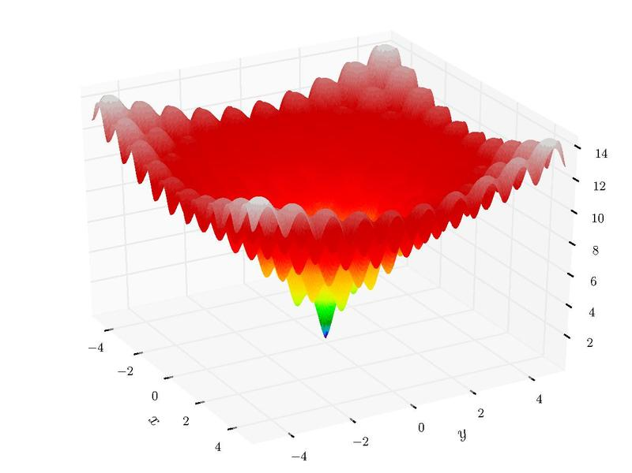](http://upload.wikimedia.org/wikipedia/commons/9/98/Ackley's_function.pdf)

Task 1. (Hill Climbing Search) (20 pts)

Implement a Hill Climbing (descending) algorithm to find the global minimum of the Ackley’s function. Adopt a maximum step size of 0.1. A new position (x’, y’) can be generated from old position (x, y) by x’ = (rand() – 0.5)*0.1 + x and y’ = (rand() – 0.5)*0.1 + y, where rand() is a uniform random number generation function generating random numbers in [0, 1).

Randomly generate an initial position. Use the Hill Climbing algorithm to optimize the Ackley’s function starting from the initial position. Terminate the optimization process when a better position yielding lower objective function value is not found in the last 100 steps. Repeat this process for 100 runs. Display the distribution of the minima you found in each run on a figure.

Task 2. (Differential Evolution) (20 pts)

Implement a Differential Evolution algorithm to find the global minimum of the Ackley’s function. Terminate the optimization process when a better position yielding lower objective function value is not found in the last 100 steps. Repeat this process for 100 runs. Display the distribution of the minima you found in each run on a figure.

Task 3. (Analysis) (10 pts)

Compare the results you obtain in the last three tasks. Draw your conclusions.

2. Traveling Salesman Problem (TSP)

The purpose of this exercise is to explore evolutionary approaches to solving TSP's, not to find other methods for solving TSP's. Your representation of solution candidates should be permutations of the digits 1..n, with crossover methods and mutations as discussed in class. Recall that traditional crossover methods do not work well with permutations, but that numerous alternative methods have been discussed in class for producing offspring that are permutations retaining some characteristics of the parent permutations, using one or two parents.

For this assignment, you should use two different techniques for producing offspring, at least one of which should be chosen from those discussed in class. Your second method can also be chosen from those, you may alternatively develop a different technique or you may research other techniques that have been attempted. You may use more than two techniques, but in any case these should be evolutionary techniques for producing offspring from permutations, and not simply some other algorithm for solving the TSP.

Report on the results (success or partial success) of your solution, along with a description of approaches you attempted. You should use the following data file for your testing.

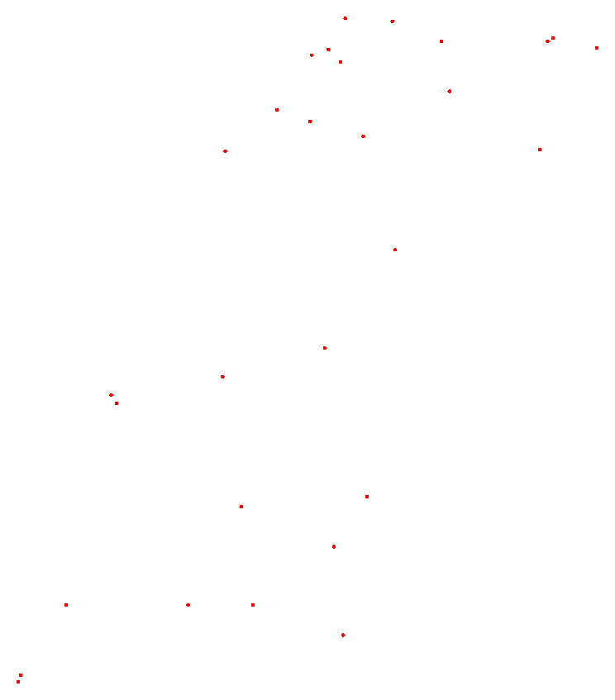

Map of West Sahara

NAME : wi29

COMMENT : 29 locations in Western Sahara

COMMENT : Derived from National Imagery and Mapping Agency data

TYPE : TSP

DIMENSION : 29

EDGE_WEIGHT_TYPE : EUC_2D

NODE_COORD_SECTION

1 20833.3333 17100.0000

2 20900.0000 17066.6667

3 21300.0000 13016.6667

4 21600.0000 14150.0000

5 21600.0000 14966.6667

6 21600.0000 16500.0000

7 22183.3333 13133.3333

8 22583.3333 14300.0000

9 22683.3333 12716.6667

10 23616.6667 15866.6667

11 23700.0000 15933.3333

12 23883.3333 14533.3333

13 24166.6667 13250.0000

14 25149.1667 12365.8333

15 26133.3333 14500.0000

16 26150.0000 10550.0000

17 26283.3333 12766.6667

18 26433.3333 13433.3333

19 26550.0000 13850.0000

20 26733.3333 11683.3333

21 27026.1111 13051.9444

22 27096.1111 13415.8333

23 27153.6111 13203.3333

24 27166.6667 9833.3333

25 27233.3333 10450.0000

26 27233.3333 11783.3333

27 27266.6667 10383.3333

28 27433.3333 12400.0000

29 27462.5000 12992.2222

EOF

Here are two maps ([Uruguay](http://www.cs.odu.edu/~yaohang/cs480/Assg/uy734.tsp.txt) and [Qatar](http://www.cs.odu.edu/~yaohang/cs480/Assg/qa194.tsp.txt)) for you to test your program.

Task 1. (Parse the TSP data file) (5 pts)

Task 2. (Genetic Algorithm) (30 pts)

Task 3. (Report and Analysis) (15 pts)

What to Hand in

1. Well documented codes implementing genetic algorithm for the problems. A README file should provide instructions on how to compile and execute the code.
2. Solutions you obtained, describing your methods, and analysis in tasks.

Please turn in your written part in class and send the programs to [dfeng@cs.odu.edu](mailto:dfeng@cs.odu.edu) before the assignment due date.